**Modern College of Arts, Science and Commerce, Pune-05**

**Department of Statistics**

**M.Sc. II Semester (IV)**

**Practical No.1**

**Title:One way classification, multiple comparison test.**

Q.1 The tensile strength of Portland cement is being studied. Four different mixing techniques can be used economically. The following data have been collected:

|  |  |  |  |  |
| --- | --- | --- | --- | --- |
| Mixing Technique | Tensile Strength (1b/ in2) | | | |
| 1 | 3200 | 3300 | 2975 | 3150 |
| 2 | 3129 | 3000 | 2865 | 2890 |
| 3 | 2600 | 2700 | 2600 | 2765 |
| 4 | 2800 | 2900 | 2985 | 3050 |

1. Test the hypothesis that mixing techniques affect the strength of the cement. Use α=0.05.
2. Use the Fisher LSD method with α=0.05 to make comparisons between pairs of means.
3. Construct a normal probability plot of residuals. What conclusion would you draw about the validity of normality assumptions?
4. Plot the residuals versus the predicted tensile strength. Comment on the plot.

Q.2 Rework part (b) of problem Q.1 using Turkey’s test with α=0.05. Does this make any difference in your conclusions?

Q.3 Reconsider the experiment in Q.1

(a) Find a 95 percent confidence interval on the mean tensile strength of the

Portland cement produced by each of the four mixing techniques.

(b) Find a 95 percent confidence interval on the difference in means for techniques

2 and 4. Does this aid you in interpreting the results of the experiment?

Q.4 A manufacturer of television sets is interested in comparing the effect on tube conductivity of four different types of coating for color picture tubes. The following conductivity data are obtained:

|  |  |  |  |  |
| --- | --- | --- | --- | --- |
| Coating Type | Conductivity | | | |
| 1 | 248 | 246 | 255 | 251 |
| 2 | 234 | 232 | 237 | 234 |
| 3 | 239 | 236 | 237 | 232 |
| 4 | 257 | 254 | 242 | 248 |

1. Is there a difference in conductivity due to coating type? Use α=0.05.
2. Estimate the overall mean and the treatment effects.
3. Compute a 95 percent confidence interval estimate of the mean coating type 2.

Compute a 99 percent confidence interval estimate of the mean difference between coating types 1 and 2.

1. Test all pairs of means using Fisher LSD method with α=0.05.
2. Use the graphical method to compare the means. Which coating type produces the highest conductivity?

Q.5 Four catalysts that may affect the concentration of one component in a three component liquid mixture are being investigated. The following concentrations are being investigated. The following concentrations are obtained.

|  |  |  |  |
| --- | --- | --- | --- |
| Catalyst | | | |
| 1 | 2 | 3 | 4 |
| 78.2 | 76.3 | 70.1 | 72.9 |
| 77.2 | 74.5 | 74.2 | 69.9 |
| 78.4 | 77.0 | 75.4 | 70.0 |
| 75.8 | 75.3 |  | 71.7 |
| 74.9 |  |  |  |

1. Do the four catalysts have the same effect on the concentration?
2. Analyze the residuals from this experiment.

Construct a 99% confidence interval estimate of the mean response for second catalyst.

**Solution**

**Q1.)**

**a.**

>Yij = matrix(c(3200,3300,2975,3150,3129,3000,2865,2890,2600,2700,2600,2765,2800,2900,2985,3050),nrow = 4,ncol = 4,byrow = TRUE)

> data=c(3200,3300,2975,3150,3129,3000,2865,2890,2600,2700,2600,2765,2800,2900,2985,3050)

>Rsum = rowSums(Yij)

>Rsum

[1] 12625 11884 10665 11735

>ytreat = Rsum/4

>ytreat

[1] 3156.25 2971.00 2666.25 2933.75

> Total = sum(Rsum)

> Total

[1] 46909

>ytotal = Total/16

>ytotal

[1] 2931.812

> SST = 0

> x = (ytreat - ytotal)^2

> x

[1] 50372.191406 1535.660156 70523.441406 3.753906

>SStreat = 4*sum(x)

>for(i in 1:4)

+ {

+ for(j in 1:4)

+ {

+ SST = SST + (Yij[i,j]-ytotal)^2

+ }

+ }

> SST

[1] 643648.4

>SStreat

[1] 489740.2

> SSE = SST - SStreat

> SSE

[1] 153908.2

> MSST = SStreat/3

> MSST

[1] 163246.7

> MSSE = SSE/12

> MSSE

[1] 12825.69

> FCAL = MSST/MSSE

> FCAL

[1] 12.72811

> FT = qf(0.05,3,12)

> FT

[1] 0.1143558

**#To test :**

**Ho : Mixing techniques do not affect the strength of the cement Vs**

**H1 : Mixing techniques affect the strength of the cement**

**Under Ho**

**F – calculated = MSSTr/MSSE = 12.72811**

**F- table = $F_{k−1,n−k,α}$ = $F_{3,12,0.05}$ = 0.1143558**

**#Since, 12.72811>0.1143558 i.e. F-calculated > F-table , we reject Ho at 5% l.o.s.**

**#Thus mixing techniques affect the strength of the cement.**

**OR**

>Yij = matrix(c(3200,3300,2975,3150,3129,3000,2865,2890,2600,2700,2600,2765,2800,2900,2985,3050),nrow = 4,ncol = 4)

>Yij

[,1] [,2] [,3] [,4]

[1,] 3200 3129 2600 2800

[2,] 3300 3000 2700 2900

[3,] 2975 2865 2600 2985

[4,] 3150 2890 2765 3050

>Yij = as.data.frame(Yij)

>Yij

V1 V2 V3 V4

1 3200 3129 2600 2800

2 3300 3000 2700 2900

3 2975 2865 2600 2985

4 3150 2890 2765 3050

> x1 = Yij[,1]

> x1

[1] 3200 3300 2975 3150

> x2 = Yij[,2]

> x2

[1] 3129 3000 2865 2890

> x3 = Yij[,3]

> x3

[1] 2600 2700 2600 2765

> x4 = Yij[,4]

> x4

[1] 2800 2900 2985 3050

> d = stack(list(b1 = x1 , b2 = x2, b3 = x3 , b4=x4))

> names(d)

[1] "values" "ind"

> model = oneway.test(values~ind,data = d)

> av1 = aov(values~ind,data = d)

> av1

Call:

aov(formula = values ~ ind, data = d)

Terms:

ind Residuals

Sum of Squares 489740.2 153908.2

Deg. of Freedom 3 12

Residual standard error: 113.2506

Estimated effects may be unbalanced

> summary(av1)

Df Sum Sq Mean Sq F valuePr(>F)

ind 3 489740 163247 12.73 0.000489 ***

Residuals 12 153908 12826

---

Signif. codes: 0 ‘***’ 0.001 ‘**’ 0.01 ‘*’ 0.05 ‘.’ 0.1 ‘ ’ 1

**#From above table too it is clear that the mixing techniques affect the strength of the cement**

**b.**

> library(agricolae)

> LSDF=LSD.test(av1,'ind');LSDF

$statistics

MSerrorDf Mean CV t.value LSD

12825.69 12 2931.812 3.862817 2.178813 174.4798

$parameters

test p.ajusted name.t ntr alpha

Fisher-LSD none ind4 0.05

$means

values std r LCL UCL Min Max Q25 Q50 Q75

b1 3156.25 135.97641 4 3032.874 3279.626 2975 3300 3106.25 3175.0 3225.00

b2 2971.00 120.55704 4 2847.624 3094.376 2865 3129 2883.75 2945.0 3032.25

b3 2666.25 80.97067 4 2542.874 2789.626 2600 2765 2600.00 2650.0 2716.25

b4 2933.75 108.27242 4 2810.374 3057.126 2800 3050 2875.00 2942.5 3001.25

$comparison

NULL

$groups

values groups

b1 3156.25 a

b2 2971.00 b

b4 2933.75 b

b3 2666.25 c

attr(,"class")

[1] "group"

> LSD1=LSDF$statistics['LSD'];LSD1

LSD

174.4798

> means=LSDF$means['values'];means

values

b1 3156.25

b2 2971.00

b3 2666.25

b4 2933.75

> if(abs(means[1,]-means[2,])>LSD1){

+ print("Reject Ho")

+ }else{

+ print('Accept Ho)')

+ }

[1] "Reject Ho"

> if(abs(means[1,]-means[3,])>LSD1){

+ print("Reject Ho")

+ }else{

+ print('Accept Ho')

+ }

[1] "Reject Ho"

> if(abs(means[1,]-means[4,])>LSD1){

+ print("Reject Ho")

+ }else{

+ print('Accept Ho')

+ }

[1] "Reject Ho"

> if(abs(means[2,]-means[3,])>LSD1){

+ print("Reject Ho")

+ }else{

+ print('Accept Ho')

+ }

[1] "Reject Ho"

> if(abs(means[2,]-means[4,])>LSD1){

+ print("Reject Ho")

+ }else{

+ print('Accept Ho')

+ }

[1] "Accept Ho"

> if(abs(means[3,]-means[4,])>LSD1){

+ print("Reject Ho")

+ }else{

+ print('Accept Ho')

+ }

[1] "Reject Ho"

**> #c)**

> model=lm(values~ind,data = d);model

Call:

lm(formula = values ~ ind, data = d)

Coefficients:

(Intercept) indb2 indb3 indb4

3156.2 -185.2 -490.0 -222.5

> res = model$residuals;res

1 2 3 4 5 6 7 8 9

43.75 143.75 -181.25 -6.25 158.00 29.00 -106.00 -81.00 -66.25

10 11 12 13 14 15 16

33.75 -66.25 98.75 -133.75 -33.75 51.25 116.25

>qqnorm(res)

>qqline(res,col='red')

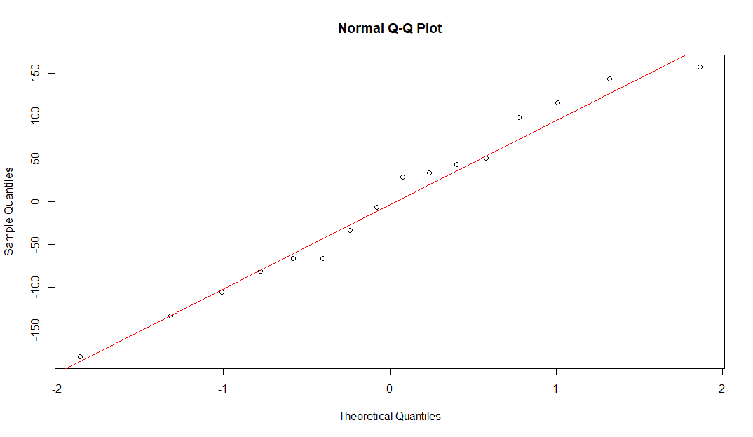

**#From the q-q plot we observe that data follows normal distribution**

>shapiro.test(data)

Shapiro-Wilk normality test

data: data

W = 0.97509, p-value = 0.9128

**#From the Shapiro test we conclude that data follows normal distribution**

**d).**

> #d)tensile strength

>d$values

[1] 3200 3300 2975 3150 3129 3000 2865 2890 2600 2700 2600 2765 2800 2900 2985

[16] 3050

> RES = Yij - ytreat

> RES

V1 V2 V3 V4

1 43.75 -27.25 -556.25 -356.25

2 329.00 29.00 -271.00 -71.00

3 308.75 198.75 -66.25 318.75

4 216.25 -43.75 -168.75 116.25

> Res=data.frame(RES,row.names = NULL);Res

V1 V2 V3 V4

1 43.75 -27.25 -556.25 -356.25

2 329.00 29.00 -271.00 -71.00

3 308.75 198.75 -66.25 318.75

4 216.25 -43.75 -168.75 116.25

> r=c(Res[,1],Res[,2],Res[,3],Res[,4]);r

[1] 43.75 329.00 308.75 216.25 -27.25 29.00 198.75 -43.75 -556.25

[10] -271.00 -66.25 -168.75 -356.25 -71.00 318.75 116.25

>plot(d$values,r,main='Residuals v/s Predictor')

>abline(0,0)

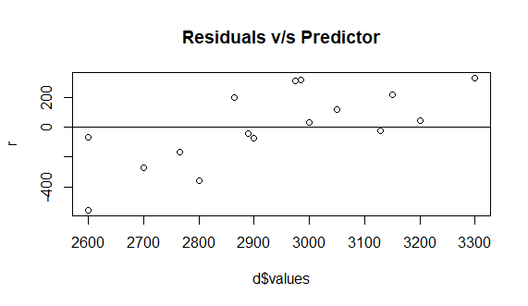

**#The above plot doesn’t show any pattern thus we conclude that normality assumptions are not violated and the data is homoscedastic in nature**

**#Q2**

> #Q2)

> T = TukeyHSD(av1,'ind');T

Tukey multiple comparisons of means

95% family-wise confidence level

Fit: aov(formula = values ~ ind, data = d)

$ind

diff lwrupr p adj

b2-b1 -185.25 -423.00029 52.50029 0.1493561

b3-b1 -490.00 -727.75029 -252.24971 0.0002622

b4-b1 -222.50 -460.25029 15.25029 0.0693027

b3-b2 -304.75 -542.50029 -66.99971 0.0115923

b4-b2 -37.25 -275.00029 200.50029 0.9652776

b4-b3 267.50 29.74971 505.25029 0.0261838

> HSD=qtukey(0.95,4,12)*sqrt((MSSE)/4);HSD

[1] 237.7503

>pvalue = T$ind[,4]

>pvalue

b2-b1 b3-b1 b4-b1 b3-b2 b4-b2 b4-b3

0.1493560850 0.0002621627 0.0693026898 0.0115922994 0.9652776222 0.0261838281

> if(T$ind[1,4]<0.05){

+ print("Reject Ho")

+ }else{

+ print('Accept H0)')

+ }

[1] "Accept H0)"

> if(T$ind[2,4]<0.05){

+ print("Reject Ho")

+ }else{

+ print('Accept H0)')

+ }

[1] "Reject Ho"

> if(T$ind[3,4]<0.05){

+ print("Reject Ho")

+ }else{

+ print('Accept H0)')

+ }

[1] "Accept H0)"

> if(T$ind[4,4]<0.05){

+ print("Reject Ho")

+ }else{

+ print('Accept H0)')

+ }

[1] "Reject Ho"

> if(T$ind[5,4]<0.05){

+ print("Reject Ho")

+ }else{

+ print('Accept H0)')

+ }

[1] "Accept H0)"

> if(T$ind[6,4]<0.05){

+ print("Reject Ho")

+ }else{

+ print('Accept H0)')

+ }

[1] "Reject Ho"

> D=duncan.test(av1,'ind');D

$statistics

MSerrorDf Mean CV

12825.69 12 2931.812 3.862817

$parameters

test name.t ntr alpha

Duncan ind4 0.05

$duncan

Table CriticalRange

2 3.081307 174.4798

3 3.225244 182.6303

4 3.312453 187.5686

$means

values std r Min Max Q25 Q50 Q75

b1 3156.25 135.97641 4 2975 3300 3106.25 3175.0 3225.00

b2 2971.00 120.55704 4 2865 3129 2883.75 2945.0 3032.25

b3 2666.25 80.97067 4 2600 2765 2600.00 2650.0 2716.25

b4 2933.75 108.27242 4 2800 3050 2875.00 2942.5 3001.25

$comparison

NULL

$groups

values groups

b1 3156.25 a

b2 2971.00 b

b4 2933.75 b

b3 2666.25 c

attr(,"class")

[1] "group"

> s=sort(D$means[,1])

**> #Q3)a**

**> #ci from lsd fisher table**

> LSDF=LSD.test(av1,'ind');LSDF

$means

values std r LCL UCL Min Max Q25 Q50 Q75

b1 3156.25 135.97641 4 3032.874 3279.626 2975 3300 3106.25 3175.0 3225.00

b2 2971.00 120.55704 4 2847.624 3094.376 2865 3129 2883.75 2945.0 3032.25

b3 2666.25 80.97067 4 2542.874 2789.626 2600 2765 2600.00 2650.0 2716.25

b4 2933.75 108.27242 4 2810.374 3057.126 2800 3050 2875.00 2942.5 3001.25

> #q3b

>qt(0.025,12)

[1] -2.178813

>cal=qt(0.025,12)*sqrt((MSSE)/2);cal

[1] -174.4798

>ul = (-37.25)-cal;ul

[1] 137.2298

>ll = (-37.25)+cal;ll

[1] -211.7298

**> #Q4**

>Yij = matrix(c(248,246,255,251,234,232,237,234,239,236,237,232,257,254,242,248),nrow = 4,ncol = 4,byrow = TRUE)

> data=c(248,246,255,251,234,232,237,234,239,236,237,232,257,254,242,248)

>Rsum = rowSums(Yij)

>Rsum

[1] 1000 937 944 1001

>ytreat = Rsum/4

>ytreat

[1] 250.00 234.25 236.00 250.25

> Total = sum(Rsum)

> Total

[1] 3882

>ytotal = Total/16

>ytotal

[1] 242.625

> SST = 0

> x = (ytreat - ytotal)^2

> x

[1] 54.39062 70.14062 43.89062 58.14062

>SStreat = 4*sum(x)

>for(i in 1:4)

+ {

+ for(j in 1:4)

+ {

+ SST = SST + (Yij[i,j]-ytotal)^2

+ }

+ }

> SST

[1] 1123.75

>SStreat

[1] 906.25

> SSE = SST - SStreat

> SSE

[1] 217.5

> MSST = SStreat/3

> MSST

[1] 302.0833

> MSSE = SSE/12

> MSSE

[1] 18.125

> FCAL = MSST/MSSE

> FCAL

[1] 16.66667

> FT = qf(0.05,3,12)

> FT

[1] 0.1143558

**#To test :**

**Ho : There is no difference in conductivity due to coating type Vs**

**H1 : There is difference in conductivity due to coating type**

**Under Ho**

**F – calculated = MSSTr/MSSE = 16.66667**

**F- table = $F_{k−1,n−k,α}$ = $F_{3,12,0.05}$ = 0.1143558**

**#Since, 16.66667>0.1143558 i.e. F-calculated > F-table , we reject Ho at 5% l.o.s.**

**#Thusthere is difference in conductivity due to coating type**

**OR**

>Yij = matrix(c(248,246,255,251,234,232,237,234,239,236,237,232,257,254,242,248),nrow = 4,ncol = 4,byrow = TRUE)

>Yij

[,1] [,2] [,3] [,4]

[1,] 248 246 255 251

[2,] 234 232 237 234

[3,] 239 236 237 232

[4,] 257 254 242 248

>Yij = as.data.frame(Yij)

>Yij

V1 V2 V3 V4

1 248 246 255 251

2 234 232 237 234

3 239 236 237 232

4 257 254 242 248

> x1 = Yij[,1]

> x1

[1] 248 234 239 257

> x2 = Yij[,2]

> x2

[1] 246 232 236 254

> x3 = Yij[,3]

> x3

[1] 255 237 237 242

> x4 = Yij[,4]

> x4

[1] 251 234 232 248

> d = stack(list(b1 = x1 , b2 = x2, b3 = x3 , b4=x4))

> names(d)

[1] "values" "ind"

> model = oneway.test(values~ind,data = d)

> av1 = aov(values~ind,data = d)

> av1

Call:

aov(formula = values ~ ind, data = d)

Terms:

ind Residuals

Sum of Squares 23.25 1100.50

Deg. of Freedom 3 12

Residual standard error: 9.576447

Estimated effects may be unbalanced

> summary(av1)

Df Sum Sq Mean Sq F valuePr(>F)

ind 3 23.2 7.75 0.085 0.967

Residuals 12 1100.5 91.71

**#From above table too it is clear that there is difference in conductivity due to coating type.**

**#b.**

#Estimate of overall mean

>ytotal

[1] 242.625

#Estimate of treatment effects

> y = ytreat - ytotal

> y

[1] 7.375 -8.375 -6.625 7.625

**#c**

> #ci from lsd fisher table

> LSDF=LSD.test(av1,'ind');LSDF

$statistics

MSerrorDf Mean CV t.value LSD

91.70833 12 242.625 3.947016 2.178813 14.75398

$parameters

test p.ajusted name.t ntr alpha

Fisher-LSD none ind4 0.05

$means

values std r LCL UCL Min Max Q25 Q50 Q75

b1 244.50 10.148892 4 234.0674 254.9326 234 257 237.75 243.5 250.25

b2 242.00 9.933110 4 231.5674 252.4326 232 254 235.00 241.0 248.00

b3 242.75 8.500000 4 232.3174 253.1826 237 255 237.00 239.5 245.25

b4 241.25 9.639329 4 230.8174 251.6826 232 251 233.50 241.0 248.75

$comparison

NULL

$groups

values groups

b1 244.50 a

b3 242.75 a

b2 242.00 a

b4 241.25 a

attr(,"class")

[1] "group"

**#95% ci for coating type 2 : (231.5674, 252.4326)**

> T = TukeyHSD(av1,'ind');T

Tukey multiple comparisons of means

95% family-wise confidence level

Fit: aov(formula = values ~ ind, data = d)

$ind

diff lwrupr p adj

b2-b1 -2.50 -22.60412 17.60412 0.9819962

b3-b1 -1.75 -21.85412 18.35412 0.9936238

b4-b1 -3.25 -23.35412 16.85412 0.9620989

b3-b2 0.75 -19.35412 20.85412 0.9994852

b4-b2 -0.75 -20.85412 19.35412 0.9994852

b4-b3 -1.50 -21.60412 18.60412 0.9959515

>qt(0.005,12)

[1] -3.05454

>cal=qt(0.005,12)*sqrt((MSSE)/2);cal

[1] -9.195382

>ul = (-2.50)-cal;ul

[1] 6.695382

>ll = (-2.50)+cal;ll

[1] -11.69538

**#99% ci for difference in treatment 1 and 2 is (-11.69538, 6.695382)**

**#d**

> LSDF=LSD.test(av1,'ind');LSDF

$statistics

MSerrorDf Mean CV t.value LSD

91.70833 12 242.625 3.947016 2.178813 14.75398

$parameters

test p.ajusted name.t ntr alpha

Fisher-LSD none ind4 0.05

$means

values std r LCL UCL Min Max Q25 Q50 Q75

b1 244.50 10.148892 4 234.0674 254.9326 234 257 237.75 243.5 250.25

b2 242.00 9.933110 4 231.5674 252.4326 232 254 235.00 241.0 248.00

b3 242.75 8.500000 4 232.3174 253.1826 237 255 237.00 239.5 245.25

b4 241.25 9.639329 4 230.8174 251.6826 232 251 233.50 241.0 248.75

$comparison

NULL

$groups

values groups

b1 244.50 a

b3 242.75 a

b2 242.00 a

b4 241.25 a

attr(,"class")

[1] "group"

> LSD1=LSDF$statistics['LSD'];LSD1

LSD

14.75398

> means=LSDF$means['values'];means

values

b1 244.50

b2 242.00

b3 242.75

b4 241.25

> if(abs(means[1,]-means[2,])>LSD1){

+ print("Reject Ho")

+ }else{

+ print('Accept H0)')

+ }

[1] "Accept H0)"

> if(abs(means[1,]-means[3,])>LSD1){

+ print("Reject Ho")

+ }else{

+ print('Accept H0')

+ }

[1] "Accept H0"

> if(abs(means[1,]-means[4,])>LSD1){

+ print("Reject Ho")

+ }else{

+ print('Accept H0')

+ }

[1] "Accept H0"

> if(abs(means[2,]-means[3,])>LSD1){

+ print("Reject Ho")

+ }else{

+ print('Accept H0')

+ }

[1] "Accept H0"

> if(abs(means[2,]-means[4,])>LSD1){

+ print("Reject Ho")

+ }else{

+ print('Accept H0')

+ }

[1] "Accept H0"

> if(abs(means[3,]-means[4,])>LSD1){

+ print("Reject Ho")

+ }else{

+ print('Accept H0')

+ }

[1] "Accept H0"

**> #Q5**

>Yij = matrix(c(78.2,77.2,78.4,75.8,74.9,76.3,74.5,77.0,75.3,0,70.1,74.2,75.4,0,0,72.9,69.9,70.0,71.7,0),nrow = 4,ncol = 5,byrow = TRUE)

> data=c(78.2,77.2,78.4,75.8,74.9,76.3,74.5,77.0,75.3,0,70.1,74.2,75.4,0,0,72.9,69.9,70.0,71.7,0)

>Rsum = rowSums(Yij)

>Rsum

[1] 384.5 303.1 219.7 284.5

> ytreat1= Rsum[1]/5

> ytreat2= Rsum[2]/4

> ytreat3= Rsum[3]/3

> ytreat4= Rsum[4]/4

>ytreat= c(ytreat1,ytreat2,ytreat3,ytreat4)

>ytreat

[1] 76.90000 75.77500 73.23333 71.12500

> Total = sum(Rsum)

> Total

[1] 1191.8

>ytotal = Total/16

>ytotal

[1] 74.4875

> SST = 0

> x = (ytreat - ytotal)^2

> x

[1] 5.820156 1.657656 1.572934 11.306406

>SStreat = 4*sum(x)

>for(i in 1:4)

+ {

+ for(j in 1:4)

+ {

+ SST = SST + (Yij[i,j]-ytotal)^2

+ }

+ }

> SST

[1] 5668.455

>SStreat

[1] 81.42861

> SSE = SST - SStreat

> SSE

[1] 5587.026

> MSST = SStreat/3

> MSST

[1] 27.14287

> MSSE = SSE/12

> MSSE

[1] 465.5855

> FCAL = MSST/MSSE

> FCAL

[1] 0.05829835

> FT = qf(0.05,3,12)

> FT

[1] 0.1143558

**#To test :**

**Ho :Catalyst does not affect the concentration of component Vs**

**H1 :Catalyst affects the concentration of component**

**Under Ho**

**F – calculated = MSSTr/MSSE = 0.05829835**

**F- table = $F_{k−1,n−k,α}$ = $F_{3,12,0.05}$ = 0.1143558**

**#Since, 0.05829835<0.1143558 i.e. F-calculated < F-table , we accept Ho at 5% l.o.s.**

**#Thuscatalyst does not affect the concentration of component**

**OR**

>Yij = matrix(c(78.2,77.2,78.4,75.8,74.9,76.3,74.5,77.0,75.3,0,70.1,74.2,75.4,0,0,72.9,69.9,70.0,71.7,0),nrow = 4,ncol = 5,byrow = TRUE)

>Yij

[,1] [,2] [,3] [,4] [,5]

[1,] 78.2 77.2 78.4 75.8 74.9

[2,] 76.3 74.5 77.0 75.3 0.0

[3,] 70.1 74.2 75.4 0.0 0.0

[4,] 72.9 69.9 70.0 71.7 0.0

>Yij = as.data.frame(Yij)

>Yij

V1 V2 V3 V4 V5

1 78.2 77.2 78.4 75.8 74.9

2 76.3 74.5 77.0 75.3 0.0

3 70.1 74.2 75.4 0.0 0.0

4 72.9 69.9 70.0 71.7 0.0

> x1 = Yij[,1]

> x1

[1] 78.2 76.3 70.1 72.9

> x2 = Yij[,2]

> x2

[1] 77.2 74.5 74.2 69.9

> x3 = Yij[,3]

> x3

[1] 78.4 77.0 75.4 70.0

> x4 = Yij[,4]

> x4

[1] 75.8 75.3 0.0 71.7

> d = stack(list(b1 = x1 , b2 = x2, b3 = x3 , b4=x4))

> names(d)

[1] "values" "ind"

> model = oneway.test(values~ind,data = d)

> av1 = aov(values~ind,data = d)

> av1

Call:

aov(formula = values ~ ind, data = d)

Terms:

ind Residuals

Sum of Squares 1064.492 4253.337

Deg. of Freedom 3 12

Residual standard error: 18.8267

Estimated effects may be unbalanced

> summary(av1)

Df Sum Sq Mean Sq F valuePr(>F)

ind 3 1064 354.8 1.001 0.426

Residuals 12 4253 354.4

**#b**

> model=lm(values~ind,data = d);model

Call:

lm(formula = values ~ ind, data = d)

Coefficients:

(Intercept) indb2 indb3 indb4

74.375 -0.425 0.825 -18.675

> res = model$residuals;res

1 2 3 4 5 6 7 8 9

3.825 1.925 -4.275 -1.475 3.250 0.550 0.250 -4.050 3.200

10 11 12 13 14 15 16

1.800 0.200 -5.200 20.100 19.600 -55.700 16.000

>qqnorm(res)

>qqline(res,col='red')

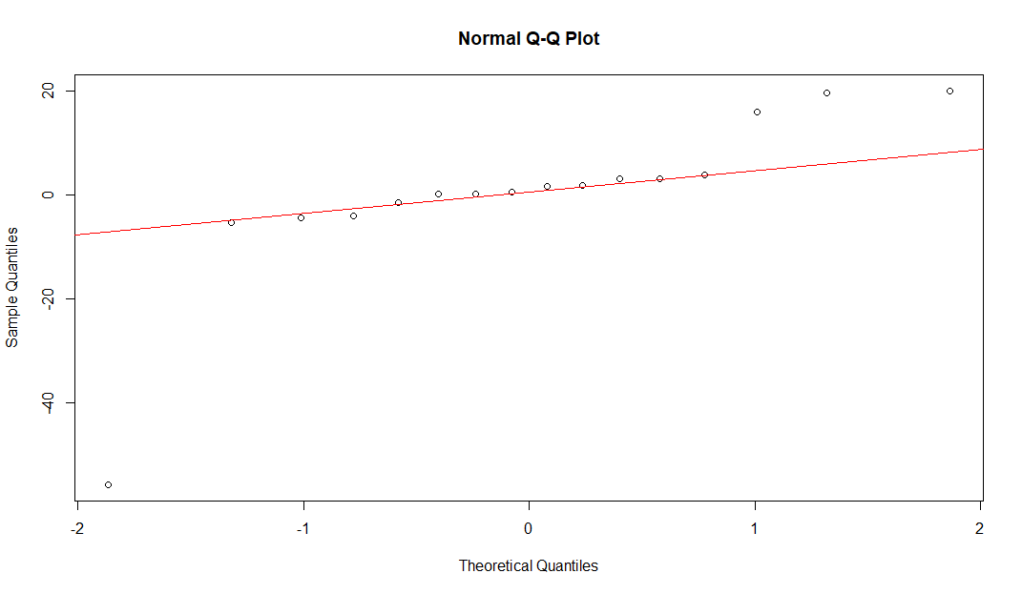

**#From the q-q plot we observe that data follows normal distribution**

>shapiro.test(data)

Shapiro-Wilk normality test

data: data

W = 0.56827, p-value = 1.405e-06

**#From the Shapiro test we conclude that data follows normal distribution**

> LSDF=LSD.test(av1,'ind',alpha = 0.01);LSDF

$statistics

MSerrorDf Mean CV t.value LSD

354.4448 12 69.80625 26.96994 3.05454 40.66353

$parameters

test p.ajusted name.t ntr alpha

Fisher-LSD none ind4 0.01

$means

values std r LCL UCL Min Max Q25 Q50 Q75

b1 74.375 3.595715 4 45.62154 103.12846 70.1 78.2 72.200 74.60 76.775

b2 73.950 3.018278 4 45.19654 102.70346 69.9 77.2 73.125 74.35 75.175

b3 75.200 3.676955 4 46.44654 103.95346 70.0 78.4 74.050 76.20 77.350

b4 55.700 37.178219 4 26.94654 84.45346 0.0 75.8 53.775 73.50 75.425

$comparison

NULL

$groups

values groups

b3 75.200 a

b1 74.375 a

b2 73.950 a

b4 55.700 a

attr(,"class")

[1] "group"

> LSD1=LSDF$statistics['LSD'];LSD1

LSD

40.66353

> means=LSDF$means['values'];means

values

b1 74.375

b2 73.950

b3 75.200

b4 55.700> means=LSDF$means['values'];means

values

b1 74.375

b2 73.950

b3 75.200

b4 55.700

**#99% ci for catalyst type 2 : (45.19654,102.70346)**